Write a program to evaluate postfix, prefix and infix expressions using Stacks.

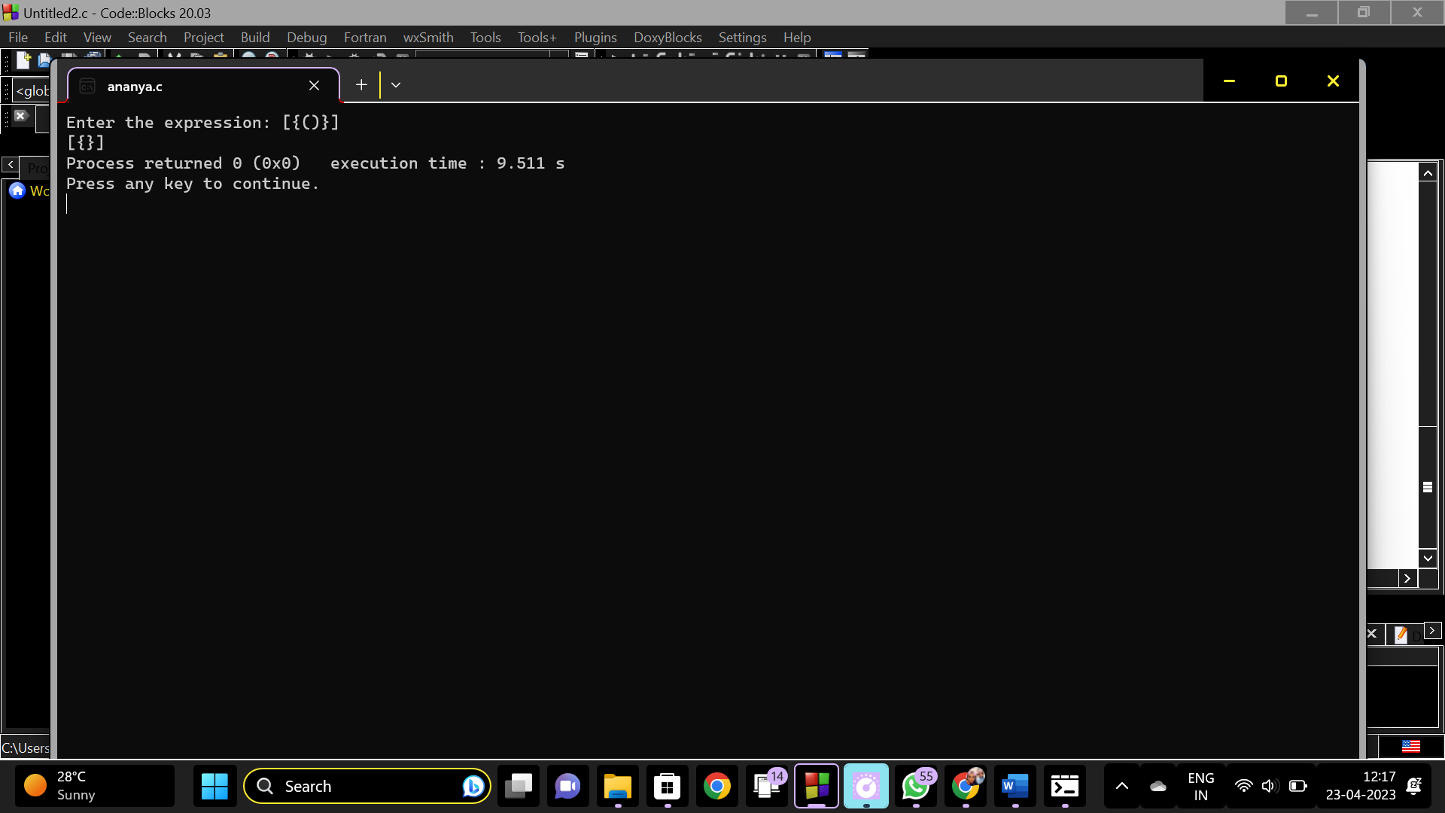

#include<stdio.h>

#include<ctype.h>

char stack[100];

int top=-1;

void push(char x)

{

stack[++top]=x;

}

char pop()

{

if(top==-1)

return -1;

else

return stack[top--];

}

int priority(char x)

{

if(x=='(')

return 0;

else if(x=='+' || x=='-')

return 1;

else if(x=='\*' || x=='/')

return 2;

else

return 0;

}

int main()

{

char exp[100];

char \*e, x;

printf("Enter the expression: ");

scanf("%s", exp);

e = exp;

while(\*e != '\0')

{

if(isalnum(\*e))

printf("%c", \*e);

else if(\*e == '(')

push(\*e);

else if(\*e == ')')

{

while((x = pop()) != '(')

printf("%c", x);

}

else

{

while(top >= 0 && priority(stack[top]) >= priority(\*e))

printf("%c", pop());

push(\*e);

}

e++;

}

while(top != -1)

{

printf("%c", pop());

}

return 0;

}